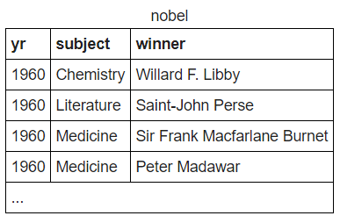

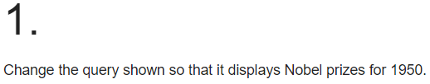

**SELECT yr, subject, winner FROM nobel WHERE yr = 1950**

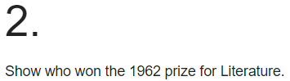

**SELECT winner FROM nobel WHERE yr = 1962 AND subject = 'Literature'**

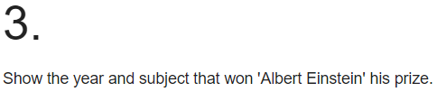

**SELECT yr,subject FROM nobel WHERE winner = 'Albert Einstein'**

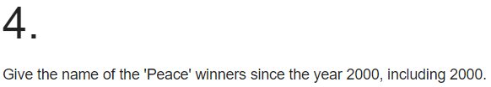

**SELECT winner FROM nobel WHERE subject = 'PEACE' AND yr = 2000 OR yr > 2000**

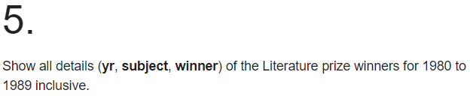

**SELECT yr,subject,winner FROM nobel WHERE subject = 'Literature' AND yr >=1980 AND yr <= 1989**

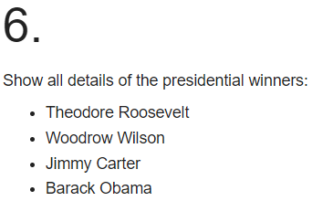

**SELECT * FROM nobel WHERE winner IN ('Theodore Roosevelt','Woodrow Wilson','Jimmy Carter','Barack Obama')**

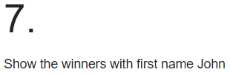

**SELECT winner FROM nobel WHERE winner LIKE'John %'**

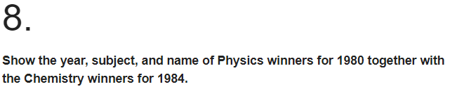

**SELECT * FROM nobel WHERE subject = 'Physics' AND yr = 1980 OR subject='Chemistry' AND yr=1984**

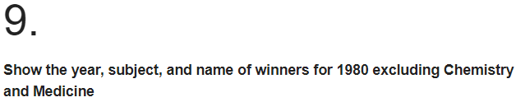

**SELECT * FROM nobel WHERE yr = 1980 AND subject <> 'Chemistry' AND subject <> 'Medicine'**

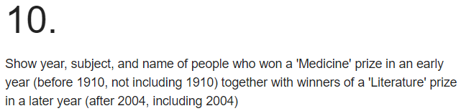

**SELECT * FROM nobel WHERE subject LIKE 'Medicine' AND yr < 1910 OR subject LIKE 'Literature' AND yr >= 2004**